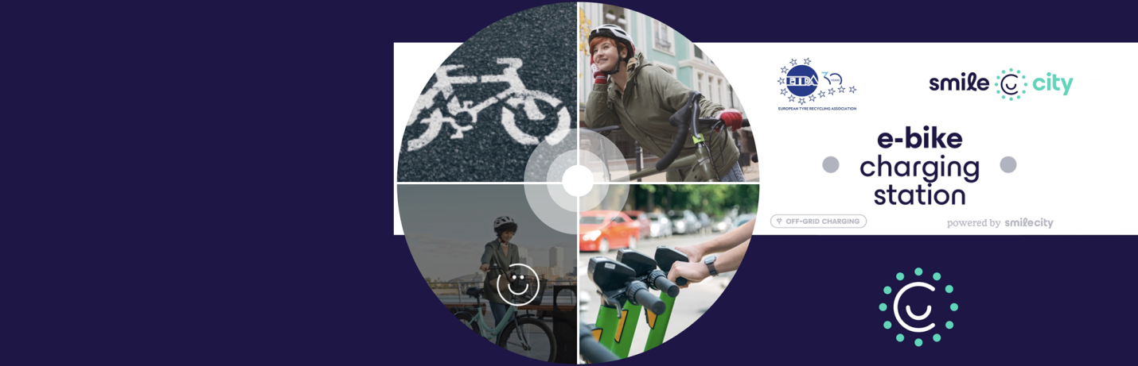
Open Call for the Faber School-Urban Living Lab “SMILE CITY” Deadline extended to January 26, 2026 h.12.00

The Faber School-Urban Living Lab “SMILE CITY” is now inviting designers, researchers, architects, makers, students, and sustainability-focused innovators to co-create a new prototype for off-grid e-bike charging stations powered by renewable energy and inspired by circular design principles.
This initiative brings together a multidisciplinary community to design and prototype solutions that support the transition toward low-emission, resilient, and citizen-centric urban environments.

Why Participate
✔ Work within a European open-innovation ecosystem
✔ Collaborate with FabLabs, technical experts, and SMILE City partners
✔ Develop a tangible prototype with real application in sustainable mobility
✔ Gain visibility during the final Demo Day
✔ Strengthen your portfolio with a Horizon Europe project experience

What You Will Design
A functional architectural concept integrating:
🔋 Photovoltaic energy production
🔄 Circular materials and second-life battery storage
🚲 Smart and accessible urban mobility infrastructure

Who Should Apply
- Students & young professionals
- Designers, architects & engineers
- Researchers & digital artisans
- Makers, innovators & sustainability enthusiasts
📅 Deadline for applications: 26 January 2026
Contribute to the future of sustainable mobility, circular economy innovation, and urban living labs across Europe.
🔗 Learn more and apply: link to the CALL

